******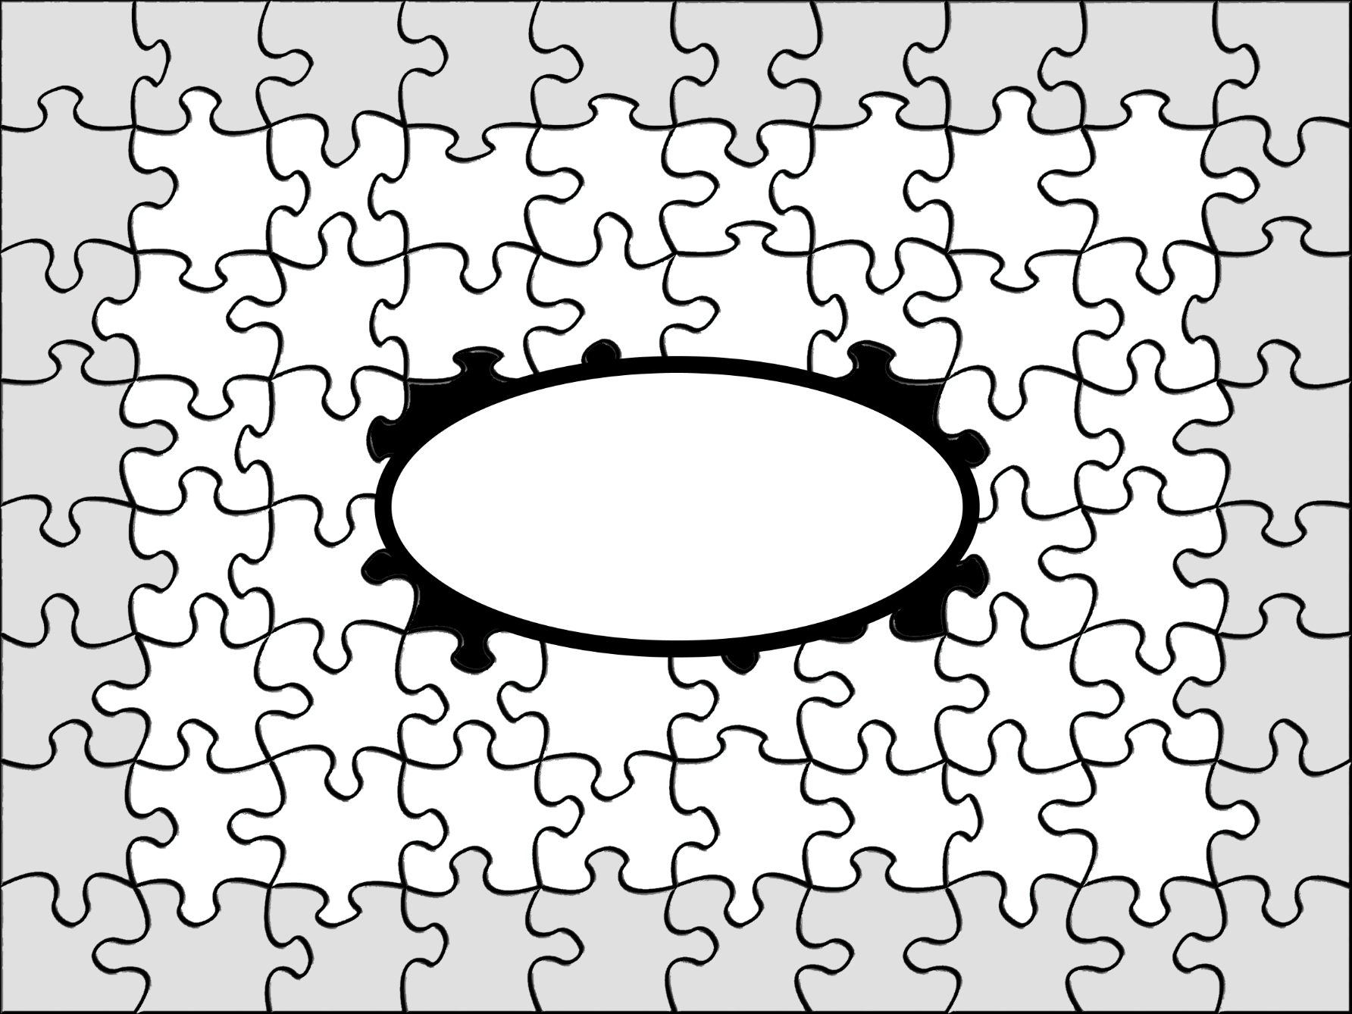**

**Scripture Legend**

**White = Truth:**

**A command or directive**

**Light Gray = Application of the Truth - a command or directive**

**Dark Gray = Seeming to violate or contradict Truth**

**Pieces that Do Not Seem to Fit**

**Rightly Dividing the Word of God**

**2 Timothy 2:15, 2 Timothy 3:16-17, Proverbs 25:2, Proverbs 14:12**

**TheAIMChurch.com**