Expect a Miracle - Jeremiah 32:27, Luke 1:37, 18:27
Call Upon Him! - Psalm 50:15, Jeremiah 29:13, Matthew 6:33

God Does Not Show Favorites (Hebrews 13:8, John 3:16-17, 1 Timothy 2:4)
However, you must take the entire Word: Psalm 119:160
- Galatians 6:7-9
- Proverbs 12:6-7, 18:20-21
- Romans 10:8, Psalm 107:20 (Romans 10:9-10)
- 2 Timothy 2:9
- Mark 11:22-24
- Luke 18:1-8
- John 14:21

God’s Desire is that You Prosper
- 3 John 2
- Deuteronomy 28:2, 7
- Psalm 107:20, Psalm 119:105, Hebrews 4:12, Jeremiah 23:2:99
- Isaiah 64:4
- Job 17:9
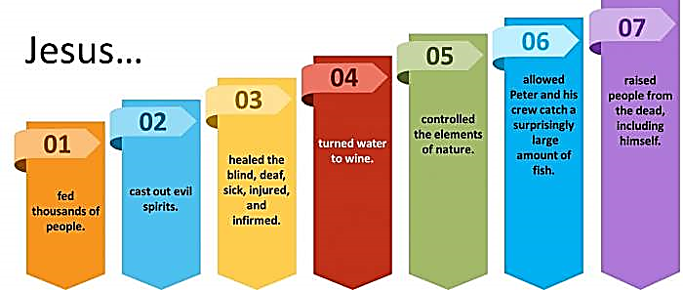
- Deuteronomy 31:6, Philippians 4:13
- Isaiah 45:2, 54:17

7 Types of Miracles Jesus Performed

When performing supernatural acts of love and power, Jesus revealed His divine nature, limitless compassion, absolute authority over nature, and showed that He is the Son of God and the promised Messiah. These miracles will build your faith and prepare you to receive your miracle today, as Jesus is unchanged and still does miracles to save and heal us.
The next page provides a list of 37 miracles performed by Jesus in chronological order, including the miracles of physical healing, Jesus’ power over nature, and bringing people back to life, including Lazarus, Jairus’ daughter, and the Nain widow’s son.
37 Miracles of Jesus in Chronological Order
# | Miracle | Matthew | Mark | Luke | John
1 | Jesus Turns Water into Wine at the Wedding in Cana |  |  |  | 2:1-11
2 | Jesus Heals an Official's Son at Capernaum in Galilee |  |  |  | 4:43-54
3 | Jesus Drives Out an Evil Spirit from a Man in Capernaum |  | 1:21-27 | 4:31-36
4 | Jesus Heals Peter's Mother-in-Law Sick with Fever | 8:14-15 | 1:29-31 | 4:38-39
5 | Jesus Heals Many Sick and Oppressed at Evening | 8:16-17 | 1:32-34 | 4:40-41
6 | First Miraculous Catch of Fish on the Lake of Gennesaret |  |  | 5:1-11
7 | Jesus Cleanses a Man with Leprosy | 8:1-4 | 1:40-45 | 5:12-14
8 | Jesus Heals a Centurion's Paralyzed Servant in Capernaum | 8:5-13 |  | 7:1-10
9 | Jesus Heals a Paralytic Who Was Let Down from the Roof | 9:1-8 | 2:1-12 | 5:17-26
10 | Jesus Heals a Man's Withered Hand on the Sabbath | 12:9-14 | 3:1-6 | 6:6-11
11 | Jesus Raises a Widow's Son from the Dead in Nain |  |  | 7:11-17
12 | Jesus Calms a Storm on the Sea | 8:23-27 | 4:35-41 | 8:22-25
13 | Jesus Casts Demons into a Herd of Pigs | 8:28-33 | 5:1-20 | 8:26-39
14 | Jesus Heals a Woman in the Crowd with an Issue of Blood | 9:20-22 | 5:25-34 | 8:42-48
15 | Jesus Raises Jairus' Daughter Back to Life | 9:18, 23-26 | 5:21-24,  35-43 | 8:40-42,  49-56
16 | Jesus Heals Two Blind Men | 9:27-31
17 | Jesus Heals a Man Who Was Unable to Speak | 9:32-34
18 | Jesus Heals an Invalid at Bethesda |  |  |  | 5:1-15
19 | Jesus Feeds 5,000 Plus Women and Children | 14:13-21 | 6:30-44 | 9:10-17 | 6:1-15
20 | Jesus Walks on Water | 14:22-33 | 6:45-52 |  | 6:16-21
21 | Jesus Heals Many Sick in Gennesaret as They Touch His Garment | 14:34-36 | 6:53-56
22 | Jesus Heals a Gentile Woman's Demon-Possessed Daughter | 15:21-28 | 7:24-30
23 | Jesus Heals a Deaf and Dumb Man |  | 7:31-37
24 | Jesus Feeds 4,000 Plus Women and Children | 15:32-39 | 8:1-13
25 | Jesus Heals a Blind Man at Bethsaida |  | 8:22-26
26 | Jesus Heals a Man Born Blind by Spitting in His Eyes |  |  |  | 9:1-12
27 | Jesus Heals a Boy with an Unclean Spirit | 17:14-20 | 9:14-29 | 9:37-43
28 | Miraculous Temple Tax in a Fish's Mouth | 17:24-27
29 | Jesus Heals a Blind, Mute Demoniac | 12:22-23 |  | 11:14-23
30 | Jesus Heals a Woman Who Had Been Crippled for 18 Years |  |  | 13:10-17
31 | Jesus Heals a Man with Dropsy on the Sabbath |  |  | 14:1-6
32 | Jesus Cleanses Ten Lepers on the Way to Jerusalem |  |  | 17:11-19
33 | Jesus Raises Lazarus from the Dead in Bethany |  |  |  | 11:1-45
34 | Jesus Restores Sight to Bartimaeus in Jericho | 20:29-34 | 10:46-52 | 18:35-43
35 | Jesus Withers the Fig Tree on the Road from Bethany | 21:18:22 | 11:12-14
36 | Jesus Heals a Servant's Severed Ear While He Is Being Arrested |  |  | 22:50-51
37 | The Second Miraculous Catch of Fish at the Sea of Tiberias |  |  |  | 21:4-11

