- Scriptures on the Spirit of Christ
- Romans 8:9, 1 Peter 1:10-11, Galatians 4:6

- There is a Trinity not a Quartet – 1 John 5:7

- Jesus / Spirit of Christ is the Savior
  - John 3:16, 1 Timothy 1:15, Acts 4:12, 1 John 4:14, Luke 19:10
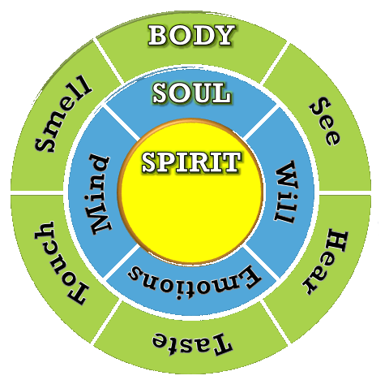
- The 3 Parts of Man
- 1 Thessalonians 5:23
- Romans 12:1-2
- Hebrews 4:12
- Our Spirit is Renewed/Saved
- Hebrews 9:14
- 2 Corinthians 5:17
- James 1:21
- 1 Peter 1:9
- Hebrews 9:28 AMPC
- Philippians 2:12 AMPC
  - From the Life- Giving Spirit
    - Genesis 2:7, 1 Corinthians 15:45, John 6:63

- Comparison of Man to the Tabernacle
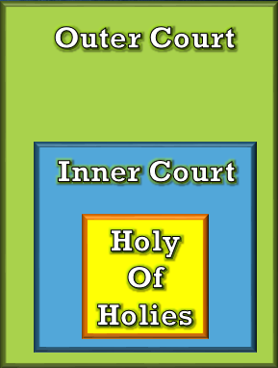
  - Revelation 21:3
  - Hebrews 9:1-15 AMPC
    - Jesus is the Door
      - John 14:6, John 10:9, Genesis 28:12, 1 Peter 3:18

- Jesus is the new Tabernacle/Temple
  - Exodus 25:8 – Build it and He (H.S.) will come!
  - John 1:14 AMPC
  - 1 Corinthians 3:16
  - 2 Corinthians 6:16
  - Ephesians 2:19-22
  - John 14:23 AMPC
  - Proverbs 24:3-4 – What should fill our house / temple
  - Exodus 31:3 & Exodus 35:31
  - Hebrews 11:3 – World was framed by the Word of God
  - 1 Corinthians 2:6-16 – Spiritual Wisdom
  - Colossians 1:9-23 – All fullness should dwell in Him
  - Matthew 25:1-13 – Parable of the 10 Virgins

- Biblical Prophecies on the Holy Spirit
    - Isaiah 44:3
    - Ezekiel 11:19-21
    - Ezekiel 36:26-34
    - Joel
  - God’s Order for Christ and the Holy Spirit from the Book of Joel
  - The Land Laid Waste (1:2-12) Genesis 1:2 / Romans 3:23
  - Mourning for the Land (1:13-20) Genesis 6:5-6
  - The Day of the Lord (2:1-11) John 3:16
  - A Call to Repentance (2:12-17) Acts 2:38
  - The Land Refreshed (2:18-27) Acts 3:19
  - God’s Spirit Poured Out (2:28-32) Acts 1:8
  - God Judges the Nations (3:1-17) Hebrews 9:27
  - God Blesses His People (3:18-21) Hebrews 9:28
  - Must We Have the Holy Spirit to be Saved?
  - Romans 10:9-10
  - 1 Corinthians 12:3
  - Titus 3:4-7
  - We Receive Christ by the Holy Spirit
  - John 14:17
  - Matthew 16:13-20
  - 2 Corinthians 5:16-17
  - John 6:44
  - Saved but Not Yet Filled with the Holy Spirit
  - Acts 19:1-6, Acts 8:5-17, Luke 11:9-13
  - Your Temple Must be Clean to Receive the Holy Spirit
  - Acts 19:1-6
  - Acts 5:32
  - John 14:15-16
  - Acts 2:38
  - Hebrews 9:8 AMPC
  - Why Will We Do Greater Works than Jesus Did?
  - John 14:12, John 16:7, John 7:39
- Why Was John the Baptist Greater?
  - Matthew 11:11, Luke 1:13-15
- When Do We Become a Child of God?
  - John 1:12-13
  - Romans 8:14
  - John 8:42, John 14:21-23
  - 2 Corinthians 6:16-18
  - Romans 8:9-19
  - Romans 8:15b - You received God’s Spirit when He adopted you as His own children.
  - Hebrews 12:7-8
- The Promise of the Father
  - Luke 24:49, Acts 1:4-5, Acts 2:38-39, 1 John 2:25
- The Holy Spirit is Our Seal
  - Ephesians 1:13-14, 1 John 3:24
- Righteousness through the Holy Spirit
  - 2 Peter 1:3, Hebrews 13:20-21, 1 John 3:9-10, 1 John 5:4&18
- Blaspheming the Holy Spirit
  - Matthew 12:31-32, Mark 3:29, Luke 12:10

