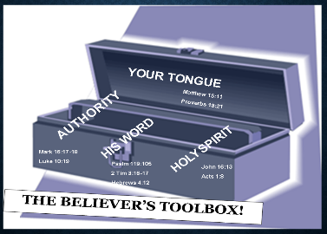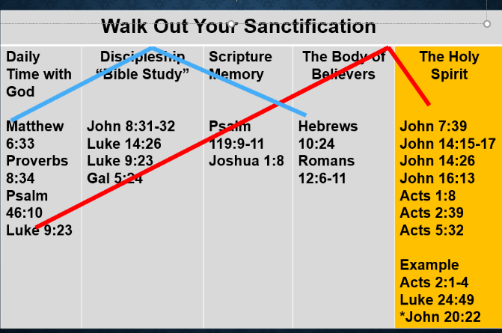

To participate in the Kingdom of God, you must be born again, John 3:3-4, and then work out your salvation, Phil 2:12, by being in the Word and applying it daily (see walk out your sanctification chart). As you walk out your sanctification you must use your tools listed in the Believer’s Tool Box.

**Key Points About the 2 Kingdoms**

* They are at war against one another
* One produces life and the other death
* Both are eternal
* Both have their own leader
* Both have their own motive
* Both have their own language
* Both have their own weapons
* Both have their own behaviors
* Both have their own support system
* Both have their own reward system
* Both have their own prayer language
* Both have their own prayer process

**Scriptures Supporting Key Points About the 2 Kingdoms**

|  |  |
| --- | --- |
| At war with one another | Mark 3:23-27 Eph 6:10-12, 1 John 3:8, |
| Produces Life or death | John 10:10, Isaiah 32:17, Rom 14:17 |
| Eternal life or eternal punishment | Matt 25:41-46, Rev 20:10, John 10:28-30 |
| Has its own leaders | Eph 1;22-23, 5:25, John 8:44 |
| Primary Motives | Isaiah 14:14, John 10:10, John 3:17 |
| Own Vocabulary | Prov 18:21, Matt 15:11, Prov 12:6-7 |
| Own Weapons | 2 Cor 10:3-6, Heb 4:12, Rev 12:11, Matt 16:19, John 14:15-17 |
| Own Behaviors/Fruit | Gal 5:18-24, 1 Cor 6:9-10, Matt 5:1-16, Matt 7:17-20 |
| Own Support System | Heb 1:14, Psalm 34:7, Psalm 103:20, 1 Peter 5:8, 1 Tim 4:1 |
| Own Reward System | Deut 28:1-14, 15-68, Rom 6:23, Matt 16:27, John 12:46-48 |
| Prayer Language | Luke 11:13, 1 Cor 14:1-4. Acts 16:16-18 |
| Prayer Process | 1 John 5:14, John 16:24, Prov 12:6 |

**Which Kingdom do you want to serve?**

According to the Word of God, (and even in our experience living here on earth), there are two Kingdoms in this world; the Kingdom of God and the Kingdom of Satan. Every person chooses daily, (whether they consciously know it or not), to live for one versus the other. Each Kingdom has its own language, weapons, behaviors, subjects, support system, etc... Which one are you serving? Hebrews 1:1-4 says that God, in the old testament, spoke to the people by the prophets. However, in these last days He has spoken to us by *His* Son (The Word of God), whom He has appointed heir of all things, through whom also He made the worlds; who being the brightness of *His* glory and the express image of His person, and upholds all things by the word of His power. Acts 17:29-31 says, we need to realize that God is not like the idols man has made of gold, jewels, silver or stone, or something created or worshipped by man. These times of ignorance, before Jesus, God overlooked, but now He commands all men everywhere to repent, because He has appointed a day on which He will judge the world in righteousness by Jesus, the Word (John 12:47-48), whom He has ordained. Jesus confirms in Mark 3:1-30, that there are two kingdoms on earth. He gave us additional knowledge about these 2 kingdoms in John 10:10; one kingdom brings life and the other brings death. Paul gave us additional instruction in Ephesians 6:12 about who we wrestle with, not man, but evil spirits. And, then in 2 Cor 10:3-6 he tells us about the weapons we use to overcome in the Kingdom of God. Which kingdom are you serving?

**Two Kingdoms: Which One Are You Serving or Living For?**